
Open Badges for LibreOffice community.
The idea we want to present here is a way to award the community using badges that recognize both their skills and their participation. It could use two combined technologies, namely Open Badges and Fedora Badges, to produce the badges automatically either for recognition or participation.

What is Open Badges:
https://openbadges.org/

In short, this is a way to recognize personal skills amongst an organization. The organization decides on the skills it wants to recognize. Open Badges represent legitimate, authenticated achievements, described within badge and linked to the awarding organization. The recipient of Open Badges can place them in a Backpack to store their badges and/or display them on their professional profile (Badges can be public or private, up to the recipient to show what he/she wants).

Each Open Badge is associated with an image and information about the badge, its recipient, the issuer, and any supporting evidence. All this information may be packaged within a badge image file that can be displayed via online CVs and social networks. Thousands of organizations across the world issue badges in accordance with the Open Badges Specification, from non-profits to major employers to educational institutions at all levels.

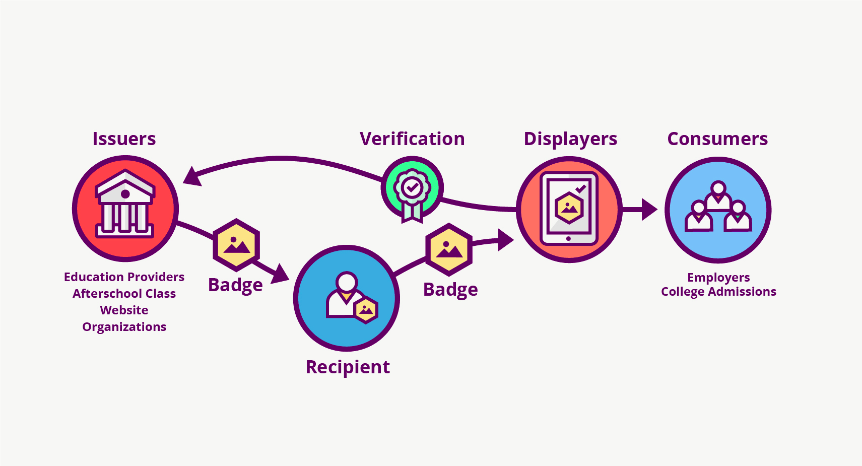
How it works:

Issuers deliver a Recipient baked Open Badge images, which she stores in a Backpack or other displayer, which verifies the content and display verified metadata to many Consumers who are interested in her accomplishments.

Open Badges specifications:
https://www.imsglobal.org/sites/default/files/Badges/OBv2p0/index.html

The Open Badges Specification defines specific methods for embedding Open Badges metadata into PNG or SVG image files. The data must be encoded into these files precisely to avoid interrupting the image display in traditional renderers like web browsers but must be discoverable by badge-specific inspection tools.

What is Fedora Badges:
It’s a platform that generates badges automatically to recognize contributors, help new and existing contributors to find different ways to get involved in the community.



How it works
People register to the program and once they begin their contributions they earn badges.
The technical part:
Fedora Badges takes advantage of fedmsg (Fedora Infrastructure's Message Bus) and datanommer to determine what kinds of contributions a person is making.
The badge awarding backend daemon, fedbadges, wakes up when it receives a fedmsg event. It compares that message and the history in datanommer against a series of rules. If a contributor matches the criteria described in one of those rules, then they are awarded a badge in real time.
The frontend that you're looking at now is a web application called tahrir. We tried as much as we could to keep Tahrir "brand agnostic", so you can install it, run it on your own platform, and issue badges to your friends! Some assembly required.

What we want to achieve
The idea is to reward contributions as well as skills using the Fedora and Open Badges technologies.
Badges for contributions could use the full Fedora technology for QA, Documentation, Marketing, Design, L10n, Infra, Development, Support and each corner of LibreOffice project (like LibOCon, booth).
While badges for skills would combined both technologies and will be determined by specific level of achievements, independent from contributions.

What we need to go further

Technical part:
At very first, we need to have somebody with the technical skills to see how it could work for us, if development or adaptations are needed and how we could host the whole process.
Then maybe explain and teach us how to manage badge creation, etc. in a knowledge transfer session. Mike to try these steps to get an overview of the badge-issuing process: https://github.com/mozilla/openbadges-backpack/wiki/New-Issuers:-Give-Yourself-a-Badge
Our single sign-on system may be useful in unifying data. We could start by using a single service from our infrastructure, eg wiki changes, and try awarding badges for them (eg a badge after 50 wiki updates).

Design part:
That could be a project for the Design team to provide the design for both kind of badges. The process defined by the Fedora community could be a good basis for that.

Defining contribution steps:
We need to specify when badges will be earned, for what contributions and at what level. We could discuss this on the marketing list, or in the community session at LibOCon

Defining skills awarding process:
We need to work with each project to define the level of achievement needed to earn an OpenBadge.

Links:
OpenBadges
Group for developers
https://groups.google.com/forum/#!forum/openbadges-dev

Group for community
https://groups.google.com/forum/#!forum/openbadges

Fedora Badges
https://badges.fedoraproject.org/
https://pagure.io/Fedora-Badges

